Use Case Realisation Report - Manage Project
FOR
Volunteer Management System
(VMS)

CLIENT
PROJECT | Volunteer Management System (VMS)
TITLE | Use Case Realisation Report - Manage Project
VERSION | 0.1a
DATE | 13-Aug-2011
 | ORIGINATOR
 | Name / Signature | Team 8S
 | APPROVAL
 | Name / Signature | Phung Kim Cuong, Dio
Institute of Systems Science |  | Document Reference
25 Heng Mui Keng Terrence  Singapore 119615 |  | VMS/PM-1.3.1/1

 | Acceptance
 | Customer Signature |  | Customer Signature
 | Name & Designation |  | Name & Designation
 | Date & Company Stamp |  | Date & Company Stamp

Revision History

Date | Version | Description | Author
12-Jun-2011 | 0.1a | Creation | Team 8S
 |  | Refer to amendment history

Table of Contents

Use Case Realisation Report - Print Certificate 3
1. Brief Description 3
2. Flow of Events 3
2.1 Standard Flow 3
2.2 Exceptions 3
3. Interaction Diagrams 4
3.1 Print Certificate 4
4. Participating Objects 4
5. Class Diagrams 4
6. Derived Requirements 4
ANNEX D Amendment History 5

Use Case Realisation Report - Manage ProjectCertificate

Brief Description
The use case enables the System Administrator to print certificate of a volunteer for the projects that he/she has participated in.

Flow of Events
The standard flow of events for this use case and any exceptions are described in the following subsections. See section 3.1 for an overview of the participating Actors and Domain Objects.

Standard Flow
Precondition: GenerateCertificate usecase has been executed
This use case provides the user interface related functionality that will be provided to the System Administrator as follows:
- When the system administrator clicks ‘Print Certificate’ button, the method MainController .printCertificateScreen() is triggered.
- The MainController.printCertificateScreen() will use the method CertificateController.getCertificate() to get the certificate for the specified volunteer.
- CertificateController.getCertificate() will use the Certificate.getCertificateData() method to get Certificate data.
- The printCertificate screen will show, and get certificate data for printing.
- The use case terminates

Exceptions
The following exceptions were identified:

Interaction Diagrams

Print Certificate

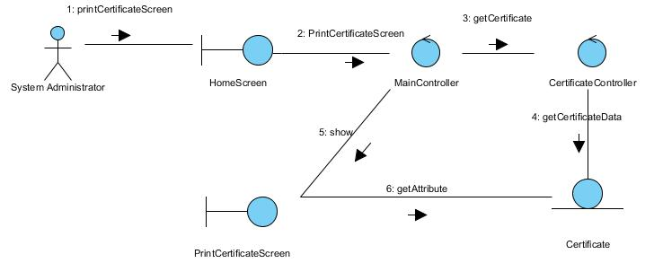

Participating Objects

Class Diagrams
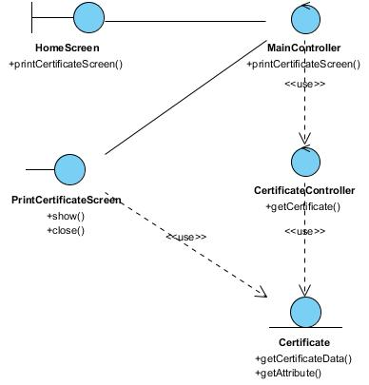

Derived Requirements

ANNEX D Amendment History

This is a record of all amendments made to the Document.
Version | Chapter / Section | Page No | Notes of Amendments or Changes

